**Assignment No. 01**

**CS610**

**ID: Bc230200839**

**Name: Zain Ul Abdeen**

**Question No. 1:**

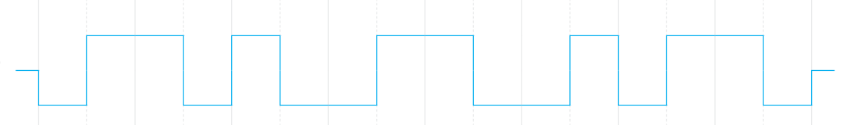

**Answer Data string** = 10010110

**Question No. 2:**

**Match the Column A to the technology mentioned in column B.**

**Answer**

|  |  |
| --- | --- |
| **A:** | **B:** |
| tracert | Hop count. each computer in between source and destination PCs on internet. |
| Data Transfer Rate | Mbps |
| Ring Topology | Broadcast |
| File Size | MB |
| Ping | Check the target PC is online. |